**NSDD Flavor Drill February 2025**

Document LA-UR-25-21584. Approved for public release; distribution is unlimited.

Title: NSDD Flavor Drill February 2025

Authors: David J. Mercer, Jennifer Auxier, and Brian Jennings. Thanks to Angela Moore at Pacific Northwest National Laboratory and Will Johnson at Sandia National Laboratories.

Date: 20 Feb 2025

**Introduction**

This is the NSDD “Flavor of the Month” drill for February 2025. The difficulty level is 6/10.

This exercise introduces a new Quick-Response (QR) code file format that allows spectra to be transferred through photographs. Low-resolution spectra (from NaI or LaBr3 detectors) can be compressed and merged into a single QR code.

The QR file format is currently available on Symetrica VeriFinder instruments (with the latest firmware update). Support for Kromek Group, RSI, Ortec/InnoRIID, and other devices is expected soon.

An overview is available here:

<https://sandialabs.github.io/InterSpec/tutorials/references/20230829_spectra_in_a_QR-code_SAND2023-08778O.pdf>

Full specifications are available here:

<https://sandialabs.github.io/InterSpec/tutorials/references/spectrum_in_a_qr_code_uur_latest.pdf>

This format is compatible with InterSpec Version 1.0.12 or later. You can download the latest InterSpec software here:

<https://github.com/sandialabs/InterSpec/releases>

To open a QR spectrum on Windows, macOS, or Linux, import the image file (JPG, BMP, PNG, or SVG) into InterSpec:

* Open the InterSpec application.
* If InterSpec is already running, select **“File”** → **“Clear Session…”** before proceeding  
  (on iPhone or Android use **“Spectra”** → **“Clear Session”**).
* Drag and drop the QR image file onto the application as **“Foreground”**
* When prompted, select **“Yes”** to use the QR code.

Drag-and-drop functionality is available in Versions 1.0.12 and 1.0.13. However, the “**File”** → **“Open File…”** option is not yet implemented.

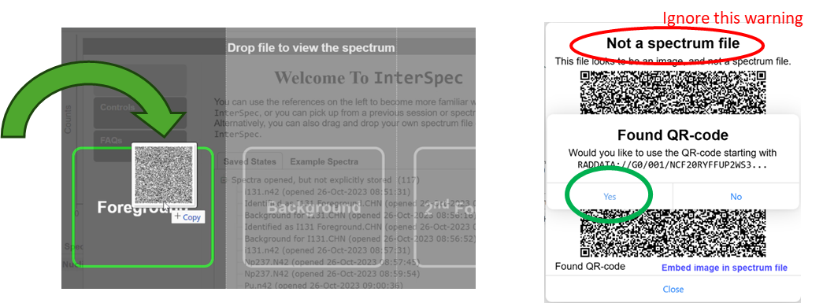

On iOS or Android devices, you may install InterSpec from the Apple App Store or Google Play Store, then use the Camera app to scan the QR code. The spectrum will open automatically in InterSpec. If the QR code is not recognized, try enlarging the image on your computer screen before scanning.

You can access all files for this drill here: <https://sandialabs.github.io/InterSpec/example_problems/flavor_of_the_month/#february-2025>

If you cannot use the QR format, spectrum files in CHN format are available at the above site. Two previous Flavor Drill answer keys, which may be useful references, are also available.

Question 1: **(Optional) Please enter your name or team name and organization.**

The next two questions are based on the file *Question 2&3 QR Image.png*. This image encodes both foreground and background spectra collected with an NaI detector. A corresponding plot, generated by InterSpec, is also provided.

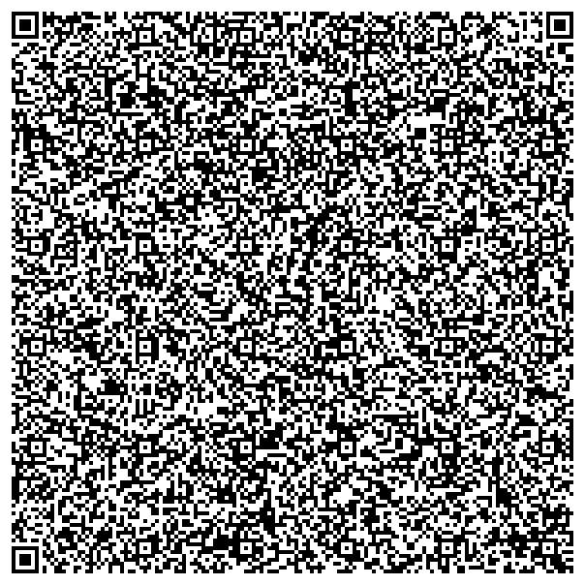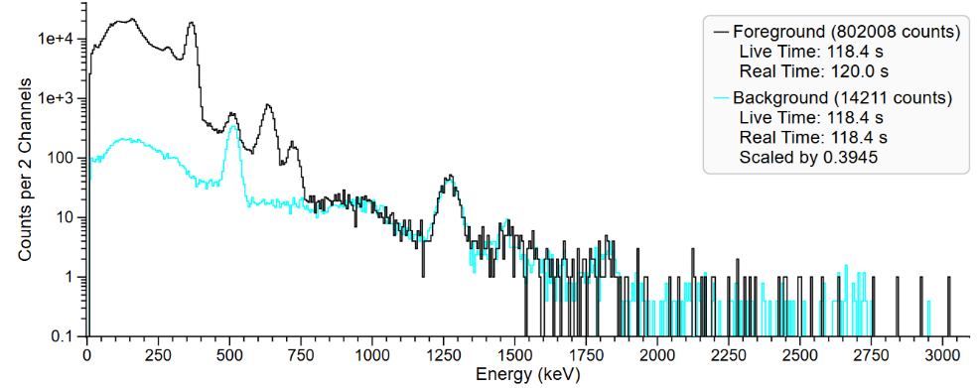

Question 2: **Which radionuclide is most likely present in the foreground spectrum?**

1. Au-196
2. Ba-133
3. I-131
4. Pd-103
5. Tl-200

Question 3: **Which radionuclide in the background is used as an internal energy calibration source in the VeriFinder?**

1. Cs-137
2. F-18
3. K-40
4. Lu-176
5. Na-22

Question 4 is based on the file *Question 4 QR Image.svg*. This image encodes a spectrum collected using a LaBr3 identiFinder with a Cs-137 internal calibration source. No background spectrum is included.

The answer key from the March 2021 Flavor Drill, Question 7, may be a useful reference.

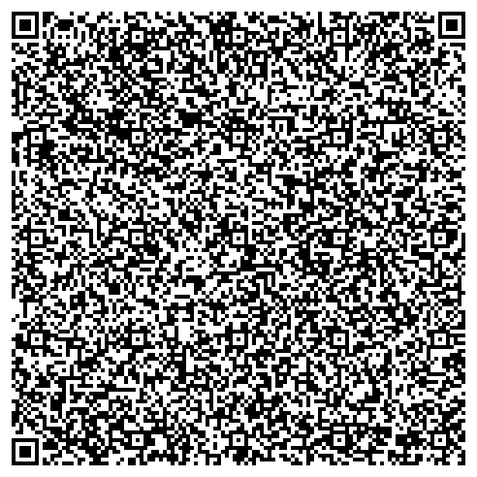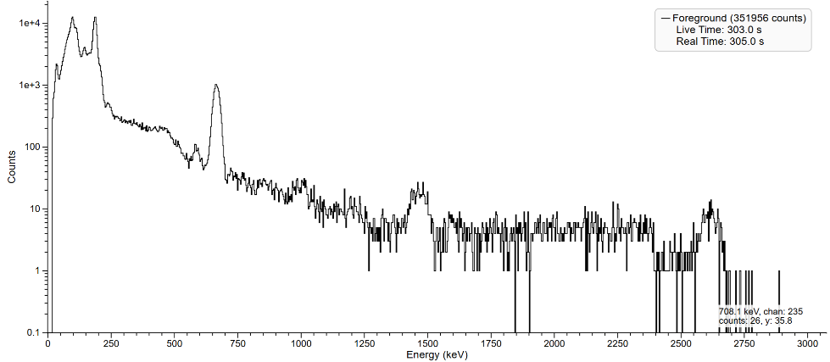

Question 4: **Which radioactive material is evident?**

1. Plutonium
2. Natural or Depleted Uranium
3. Enriched Uranium (U-235)
4. Cu-67
5. Ho-166m
6. Uranium-233
7. Neptunium-237

Question 5 is based on the file *Question 5 QR Photo.jpg*, which contains a photograph of a VeriFinder instrument screen displaying a QR code. To increase the challenge, the converted spectrum is not provided, so you must use InterSpec. The image below has been cropped and rotated for clarity.

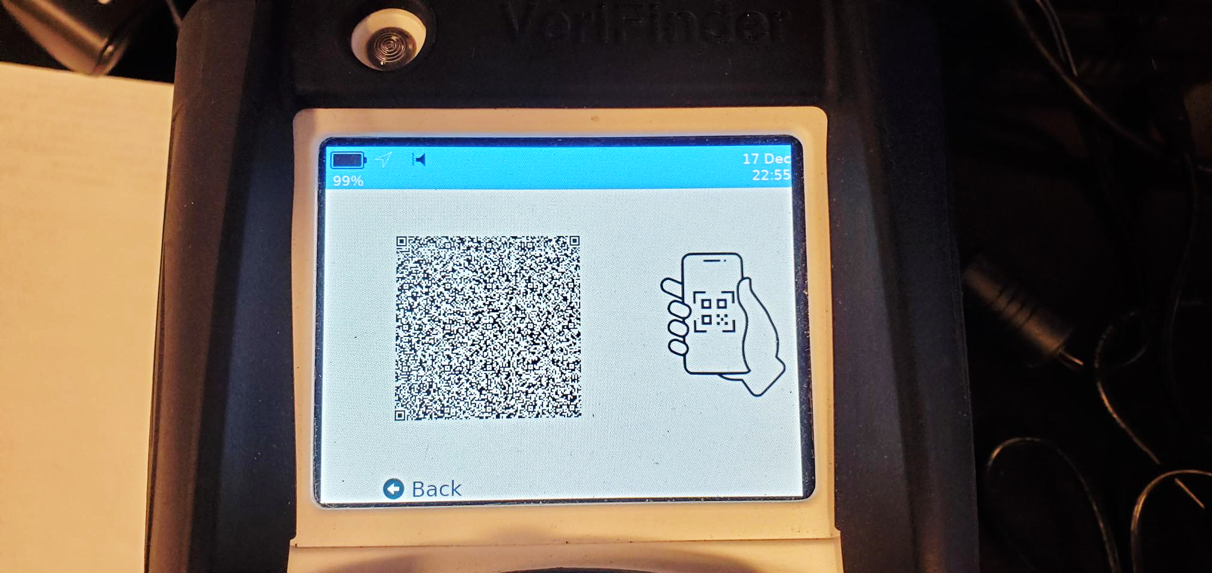

Question 5: **Which radionuclide is evident in the foreground?**

1. Am-241
2. Ba-133
3. Co-60
4. Cs-137
5. U-238

Question 6 involves analyzing a plutonium measurement using a VeriFinder instrument. The file *Question 6 QR Photo.jpg* contains a photograph of the instrument screen. The image below has been cropped and rotated for clarity.

The answer key from the November 2020 Flavor Drill, Question 7, may be a useful reference.

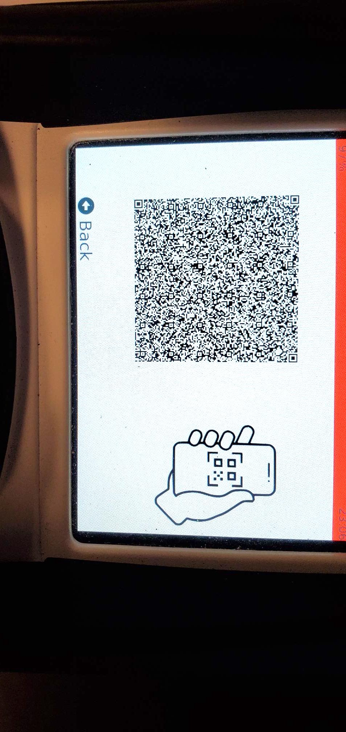

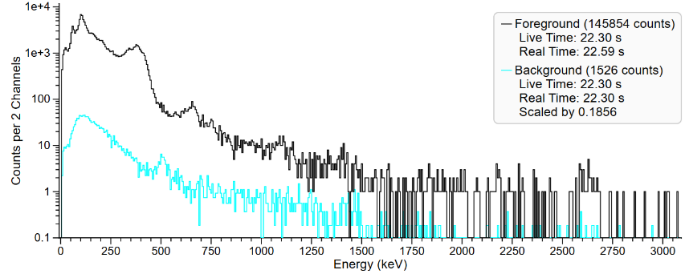

Question 6: **Which plutonium burnup level is most likely?**

1. Weapons Grade (low burnup)
2. Reactor Grade (high burnup)

Question 7 is based on the file *Question7 URL.txt*, shown below. This is a spectrum of a different plutonium sample that has been stored in a URL variation of QR encoding (some instruments offer this option for email transmission). The URL is ASCII text that stores the spectrum data. The file may be dragged-and-dropped onto InterSpec, or you may use **“File”** → **“Open File…”**, or you may copy and paste the text into InterSpec using “**Edit”** → “**Enter Url**”.   
No background spectrum is available.

RADDATA://G0/000/NCF2%3ARM%24DEP2Y53%3AMRA4W3%2FJGOR*6M%247UF%20RE%2FH2KF%2BEVJ0J1I1TQR8J1R5IAQH%24VQVN9C35B18%2BG5XZ08D3E%258QPODQ1%20863U2LK2ZR9LY9ESGUT2LVGHV57%3A7XJQ%2512O8476C5HHLX067EKTV%25J6M5OKP6CL6%20AUA-4VPUM8EFG22VLQMQI7DE%252H.2%25N93KIU%2FKTS8IR5WTB%2B%2FN2GMP*9JQCS7DEUSZ-HTR8ZFI-%3AM1UI%2F5QVW6VZDEOFO-GM3USZR0FVHSEXAR%20RR%24PL%3A*7T9TE-2525%20*I%24WN*T4166RJMZMREDMYCR%2BJNVSCV%2BRC%248Q.ENC51-Q9KK07L%24%3AR0KCJGMC187OEF%2B1J9NTW3QXVB%2F09%24V4%25PWIS0%3A4%24*AMXH%25GB8%24T%3AYAJ%25T84SA2ATOJ%25WHNPTUG0L.FP1CI5PT%2FDITO8WGPRG%20E5FFQ9PKYUGOHUTPK%246H.WV5%251%2B*KI8VMTN2JM.RN3VR%24PN811%20ZV%2FWJSZ4VN1OMSVUSDV05%2B6UMUN36CR0%20MEVRF6GSBX0USBE%2F9IP0YQCQD47YKB66JE0S%2F0J-D7KNYHD8%2FO5KAM1W%2F74%3ATB%2BMGE-L%2FAS-KUJ%2BD670Y%2BRF61%255HB%20Q37D%2FVGLZBANFR16UKFIZT19T5NT0U1UV5QRBO%25QTF5F7LV%2F6KF35RA9Y8B%2F29JLRJK6JLLENP3D46Q5NQ8L2A.B%3A%2BV%20MTUN5-6MGGR%2BMD%200HU5EU6POAOH6EG2K.8J4ZRTEUL6RU.ECBBPOA%20XP%2FAQN6K6LMVZTV5Q%2F%3AHK%25VZ1JAR9.PA%20V0LXL3CL8UB3%25J-IF31ITDS%25%3ANHNMZ6GO99S1R%2F5FVG5%2FRC5F399OLZ92%3AODH6Q5UR9O-4F%2FE0%25%24GPHV9*RR%25T25VJZU1ORRR50K8MBNKFBQSG5LTD%25Q%3ASTXQT4X2A8UAC2%25G673HAMSC47X7T9%2FO%2F%24075H9CNQ%2530XR048%3A82ARAGFU%25R7XU1R%3A2SGEPSHJTITI63%24PM%2B4O9W%20%2FEJEDE13GUHP59D8A7Q3V*9IM8XIG*CET%2FB%24%2BT35E5TKO8ODN4RSO%2B5TQDEV4U%2FRFP%20701K6%3A6TXU%3ARFF%24DPZ6-6IZOPH9LR%2BUGPL5F7TN8SWGUVI9LP*ZO0PK78AXK3BR2XC0GAKK%20OWO0*JSIAR0*75QV3IGXM7K1SZ6EV2QCSBSZVLRF%2B-A1X592R7-VTBQT3RN%2B51%2FL7NJ%2B%20AWBLD1A%24Y8B.ILJL%25%244*J1.3T%24%2BADG8EOQY%24MFW4IRH-QOE%3AV3P7A5KB%25UX6LEJ142KM4J9SPAVM%2B%2B7AYR18K%24148MR.90-28%20SP0R7JP7DHU%24-BCK1R%20NNYP*T5M%20TGH6NJRYM97P11P6-*3NDC5UU*ML3OJ3A4Q-DLE5LTNG7C15R5X10%25EZOJP%2BGVGK0.P%20%2B0KBOE56U.ROBMB8NAEF9KJIGQGDG%2F0VPZBEPN%20DFRU04%2BT.P7O3JT%20QI.7Y7L42WW4C64E-%25F%248O*C735MDNL0A1*8BUIIW138JJYEHL06IMKFLCXGLWK4%20NHIJCQ2FPPMK%24AG8UW0IFSA%24A9JMPW*5ROHBE9SMS5L4-RSZCB%2FOL5R0SOU5YHZMP1G6OJ1DHAC%3APL8F%2FG9%207QJH2BJIULH5XO.74Z-9PQ5F7J%20N23EDE2CT5LRI5QY9LEQ2J2-1J0M7Q48U%2B8M%2BH6X6AO8J0M1E3%2BR6LMIP%2FQGGM1-UL-203EZ0FOXC.LR6JC2K8LU1%2BVH182-%25HAWAXSHX25*R1GMUBZ2CNJDEB8HK%240IXR4WO1%20MANY9Q%2FHW55*CE%25LJSD9MMKR0JV8BW%3ASQ-4P%2046RD.XKGRLNCAC5I%2502.*EUVSD744ZUFMM4%20AC8TCQ11AB5JMHV3L%2FI%2B8G7GKI00SV97T09A6DII%2B13%2BVGXTOH12H%2B9K%2BC888I31R8F%25.C.-28IMCN2BS1ELGOCJG*CTVI%3ABPJ%20GCZGQZOL%2F9IW8ACJX%24C%2FBQS8ESV4TJN1UTUAW2LK2X6

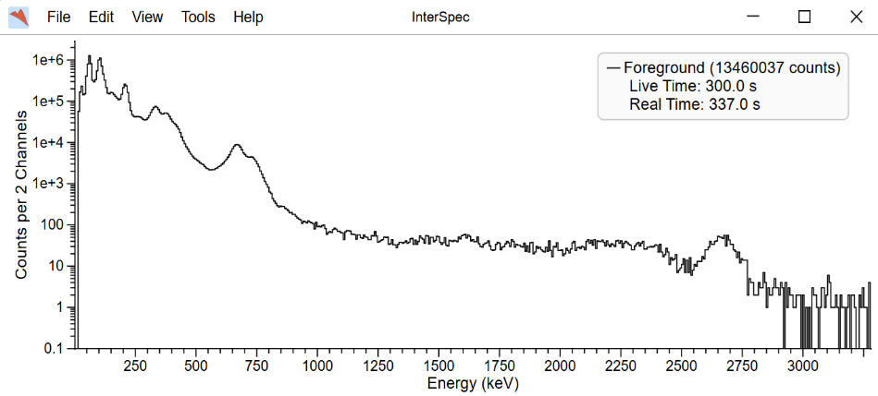

Question 7: **Which plutonium burnup level is most likely?**

1. Weapons Grade (low burnup)
2. Reactor Grade (high burnup)